3.3)

The distributions are fairly similar aside from the couple outliers in the female data set. They are both left leaning histograms.

3.4)
a)

b) There are 89 total worms total found
c)
Worms/Eel (x) | Number of Eels Containing x Number of Worms | Frequency | Cumulative Frequency
0 | 16 | 0 | 0
1 | 7 | 7 | 7
2 | 4 | 8 | 15
3 | 3 | 9 | 24
4 | 2 | 8 | 32
5 | 2 | 10 | 42
6 | 1 | 6 | 48
7 | 2 | 14 | 62
8 | 1 | 8 | 70
9 | 1 | 9 | 79
10 | 1 | 10 | 89

3.6)

Bin | Frequency | Cumulative Frequency
60 | 0 | 0
70 | 2 | 2
80 | 0 | 2
90 | 1 | 3
100 | 1 | 4
110 | 0 | 4
120 | 3 | 7
130 | 1 | 8
140 | 1 | 9
150 | 0 | 9
160 | 1 | 10
170 | 2 | 12
180 | 6 | 18
190 | 3 | 21
200 | 9 | 30
210 | 5 | 35
220 | 1 | 36
230 | 0 | 36
240 | 2 | 38
250 | 3 | 41
260 | 2 | 43
270 | 2 | 45
280 | 0 | 45
290 | 4 | 49
300 | 3 | 52
310 | 4 | 56
320 | 8 | 64
330 | 6 | 70
340 | 4 | 74
350 | 4 | 78
360 | 2 | 80
370 | 6 | 86
380 | 1 | 87
390 | 2 | 89
400 | 3 | 92
410 | 2 | 94
420 | 3 | 97
430 | 0 | 97
440 | 2 | 99
450 | 0 | 99
460 | 1 | 100

3.8)
a)

b) There were a total of 770 larva found
c)
Larva/Leaf | Number of Leaves Containing x Number of Larvae | Frequency | Cumulative Frequency
0 | 10 | 0 | 0
1 | 15 | 15 | 15
2 | 27 | 54 | 69
3 | 18 | 54 | 123
4 | 38 | 152 | 275
5 | 57 | 285 | 560
6 | 22 | 132 | 692
7 | 5 | 35 | 727
8 | 2 | 16 | 743
9 | 3 | 27 | 770
10 | 0 | 0 | 770

3.10) https://doi.org/10.1038/s41598-024-56750-7
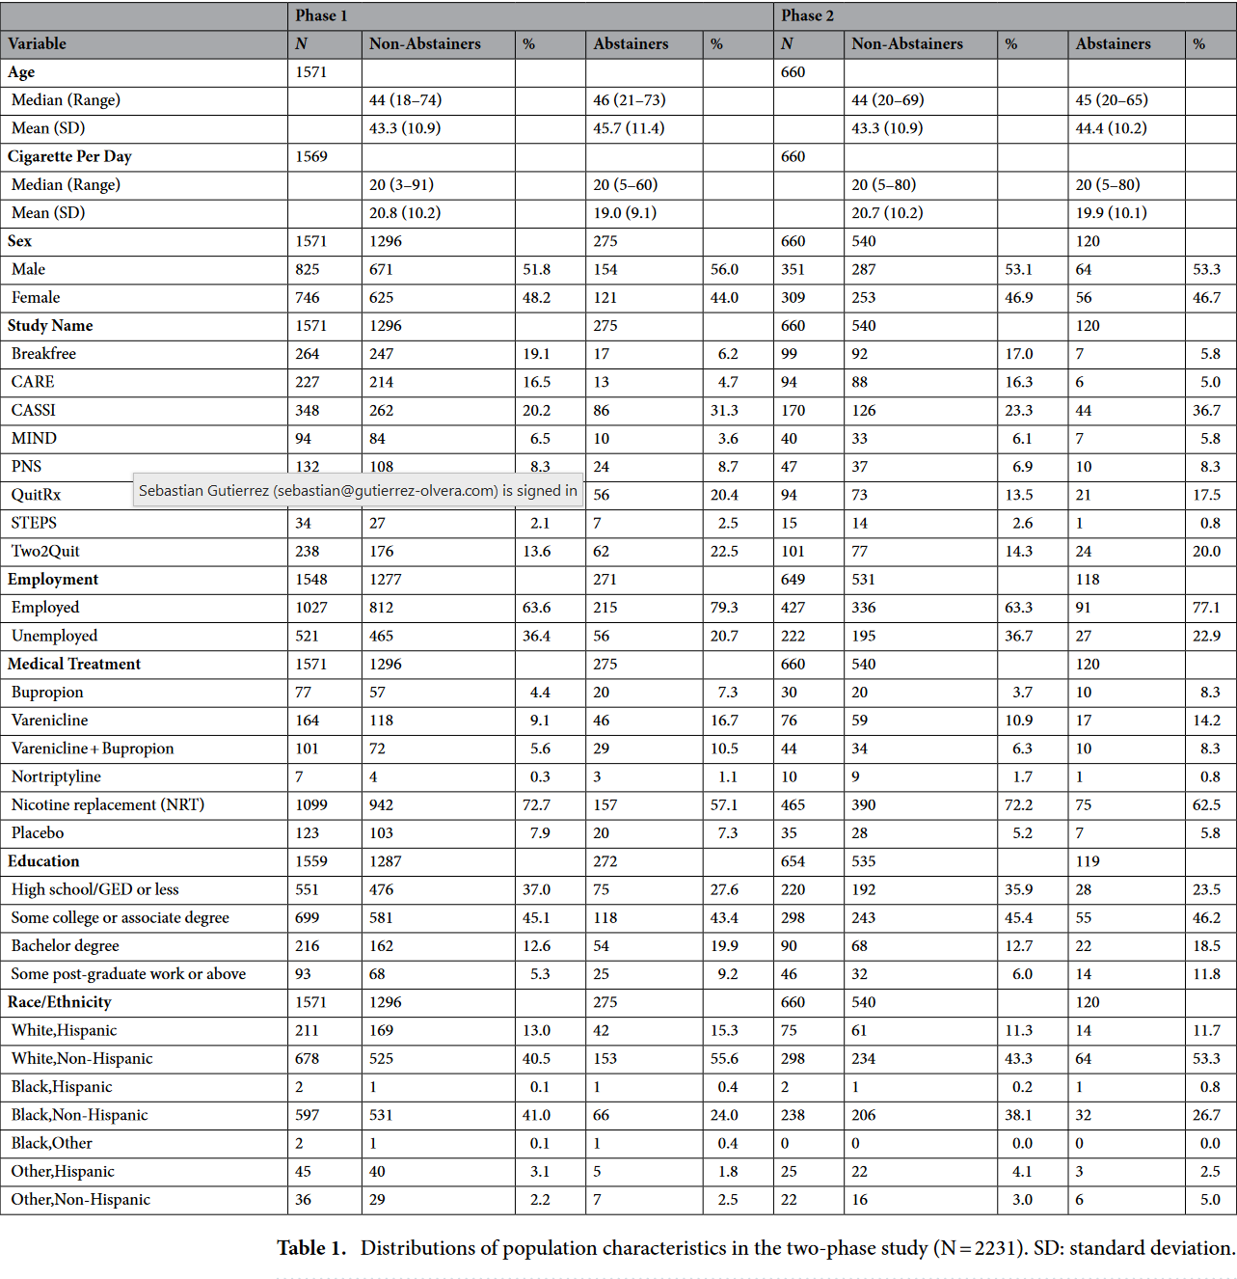

4.2)
4.3)
4.5)
4.8)
4.10)

